

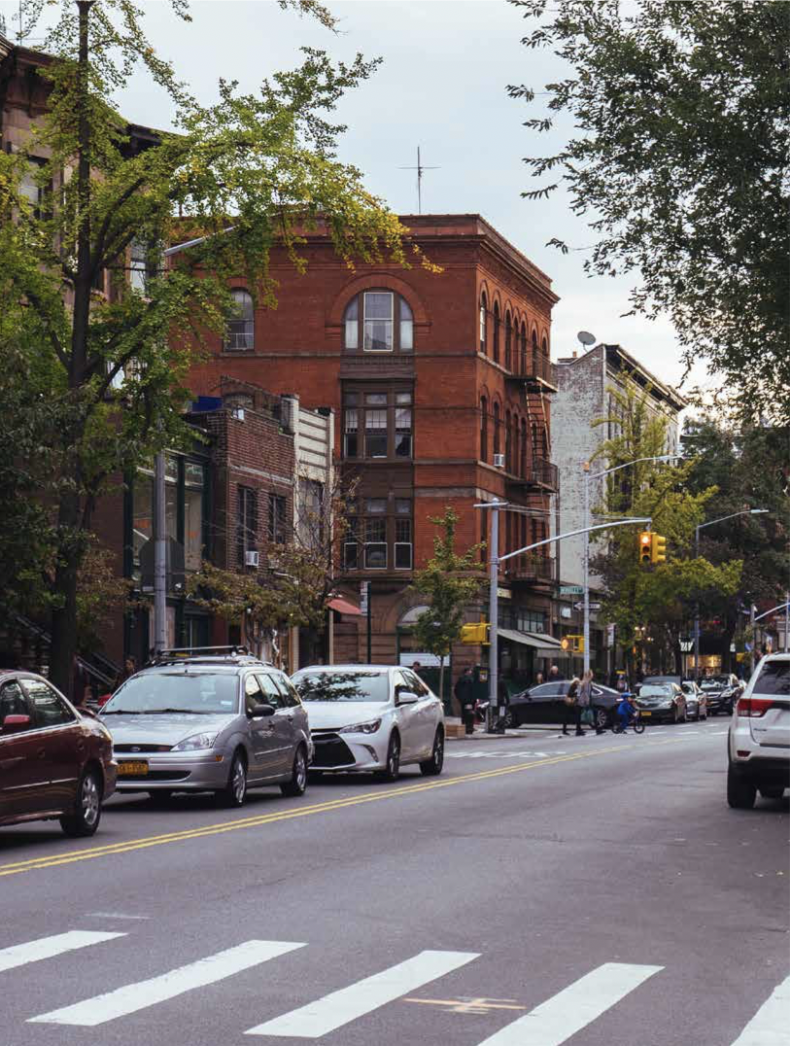
Lori Samlin Miller
White Cane Awareness
The use of a white cane by a person that is blind or visually impaired is an opportunity to recognize this helpful tool as both an important symbol of blindness and instrument of in- dependence. Rochel is a busy wife, mother, and teacher. She is visually impaired since her teen years. She relies on public transportation in order to visit her students with visual impairments in their various schools, and navigates her way through the busy streets of Brooklyn. Using her white cane, Rochel detects obstacles, stairs, and numerous types of ground surfaces. The white cane also helps alert drivers to the presence of a pedestrian that is visually impaired.
Rochel shares that “In the beginning I had conflicting feelings about using the cane-which I consider my ‘frenemy.’ On the one hand, I have fairly good peripheral vision and notice most things in my way when they are close. Yet, there are rare occasions when I don’t notice obstacles-especially in areas I’m not very familiar with”. At the end Rochel decided to use the as a ‘badge of identification,’ which I’m not always interested in wearing and advertising. Nonetheless, it comes in handy when I’m in need of help and saves explanations. The cane also alerts unsolicited guardian angels who are on the lookout for my well-being or maybe for their own by being too curious...
Rochel is a recent graduate with a degree in Teaching the Visually Impaired, yet she has not found a proper full-time job locally. There- fore, she commutes to Brooklyn to work with some Yiddishe students once or twice a week. Rochel is not a born and bred city kid. Therefore, her travel experiences are an adventure which are compounded by her visual impairment.
In the city (Brooklyn) Rochel generally uses her cane to walk around town as she is not familiar with the streets. The cane adds a level of security and comfort. Rochel also uses several navigation apps on her phone to help her know where she is when she can’t read the street signs. Furthermore, she uses the Access-a-ride service or gets them to authorize taxi reimbursement. It’s a learning curve to get the feel for a new area and to figure out the transportation options and with the addition of the visual impairment it is a challenge. Rochel recorded and reports her experiences of one of her first days at work, when she was still learning the routine and the area.

I take the 7:45 AM bus to Williamsburg and decide to try walking to school #1 instead of using any transportation so I can get some exercise. I have finally figured out Sound Scape is the best app that keeps announcing upcoming intersections as I walk. It’s going well until I approach an intersection and notice a noisy truck in the middle of the street-right where I need to cross- but can’t exactly see what’s going on. I walk a bit to the side trying to decide whether to just walk over to the next block and cross there, when a construction worker comes over to me and offers his arm and tells me he will help me cross. I tell him I can see enough to follow him and he guides me to the other side safely. Breathe...
I wonder what all the mothers waiting for their kids’ buses are thinking observing this ... but who cares? I’m on my way...
I get to the school with no further hitches. I have a very productive session with my student and need to move on to school #2 in Boro Park. I schedule a Lyft car service. It is great that they provide exact in- formation as to the type and color of the car and arrival time. Yet when it says the car arrived, I do not see a vehicle resembling their description (my limited vision makes this more complicated of course), so I call the driver. I suggest he sound his horn so I can follow the sound to his car. This trick works and I realize he’s one block over. The ride to the next school takes close to an hour instead of the half hour I had calculated it would take. My student is a bit upset we will have a short session. This will only be for today I tell her. I’m outside the door at right about 12:45 when Access-a-ride is supposed to pick me up. I receive a message from them at 12:53 that I will be picked up in 12 minutes. Uh oh... At 1:15, when they are still not there, I call Access-a-ride and tell them to change my destination to school #4 where I need to be for 1:45. They say I can’t do same day changes and put me on hold to talk to a supervisor.
... “Should I just dare to walk?” I ask myself. Previously when I came from the other school to this school, I was told “Just walk straight down but, as I can’t see more than a few feet ahead of me, I suddenly found myself on a New Utrecht Island and ran across the street with my heart in my hands. I was then advised to walk through the next street to avoid New Utrecht. But I was also carrying a Braille writer-15 pounds of metal... Nothing doing... I insisted with the supervisor at Access-a-ride that they at least approve taxi reimbursement and he agreed.
So off I go with an Uber to school #4. While I’m working with my pre-school student who can remember words like ‘Chameleon’ after hearing it only once, my phone rings. Ooops-I’d forgotten to mute it be- fore starting my session. Too late! My student hears ‘929’ (area code) and asks me what ‘929’ wants. I say I’m not sure who that is and it’s probably not important. She thinks maybe they are calling a wrong number. I finally get her back on track. And then when the session is over and I listen to my voicemail, I realize access-a-ride in their brilliance didn’t cancel my ride from school #3 to school #4 and it had been the driver waiting outside. Yikes! Hope it doesn’t give me negative points with Access-a-ride.

For the final leg of my trip, I need to take the bus back home. It passes a block away from school #4 but I’m too nervous to have to flag it down at an unofficial stop. Maybe I won’t see him coming soon enough and he’ll pass right by? I had tried to reach out to some friends to see if anyone wants to spend some time with me while walking to the bus and helping me flag him down. But that didn’t work out. I have a full 30 minutes, so I decide I will walk to the very first stop.
With my cane in hand, I venture out. I first hold the cane to one side-which gives a bit less protection but doesn’t require constant movement. I have to circumvent a group of adults? High school kids? They don’t look Jewish, and are all looking down, probably at their phones. I’m so focused on this that I don’t notice a large piece of furniture or something right in the middle of the sidewalk and bump right into it. You still need to concentrate when you use a cane. I don’t get hurt because it is wrapped in soft plastic yet I am feeling self-conscious. This doesn’t happen often.
Ok, I’ll be more careful now and use the touch technique, swinging my cane from right to left. A block further my cane gets stuck in a hole from the swinging and the bottom tip comes loose. The next block it falls off altogether... Should I just fold up the cane and put it into my pocket book? No, I’ll just hold it a bit in the air and keep walking. I’m almost at the bus stop. I ask some- one where it starts and she clearly describes where to go. I’m waiting at the last traffic light for traffic to go across indicating I can cross as I don’t see the ‘walk’ signal. But there is no traffic in that direction. It’s getting close to departure time... A lady asks me if she can help me cross. I say “No thank you, I just wanted to make sure it’s safe to cross now,” and I cross. I walk up close to the bus to see if it’s the right bus by reading the large letters, and it is. Phew, I made it. Boruch Hashem!
Rochel Y is the co-founder of the organization, Insight Beyond Eye- sight, providing support, information, and networking for Jewish individuals who are visually impaired and their families; host events throughout the year including family get-togethers and teleconference calls where members can spend quality time together, share resources and ideas; and gain inspiration and helpful knowledge.
For more information, contact: insightbeyondeyesight@gmail.com or https://insightbeyondeyesight.org
Lori Samlin Miller, writes from the heart. She is a busy journalist, a former Special Education Teacher, and the author of two popular children’s books: Stay Where I Can See You, and, We’ve Come to the Road, and the middle grade novel: No Prayer is Ever Wasted. Her books are currently being recorded and will soon be available in large print format and Braille. Contact her: lori.samlin.miller@gmail.com or www.lorisamlinmiller.com

